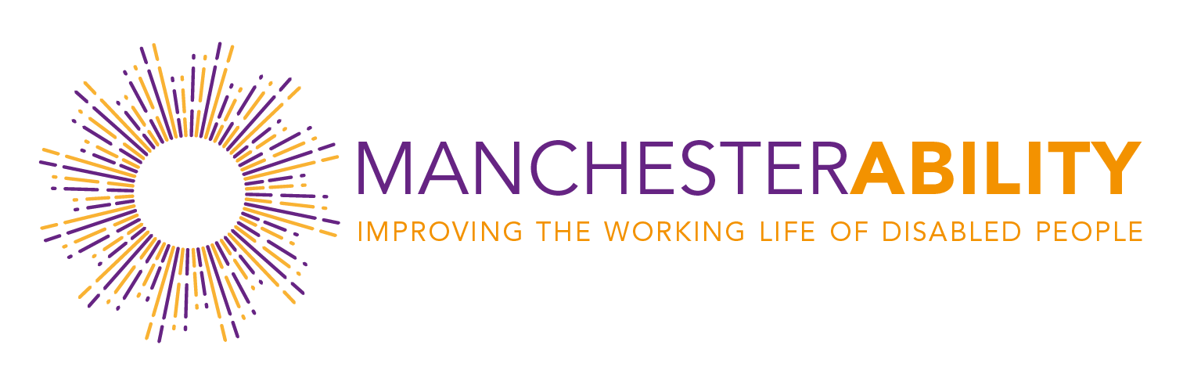

Guiding principles for members of the ManchesterAbility network

Mission statement
ManchesterAbility, founded in 2018, is a cross organisational forum in Manchester which brings government, companies and other organisations together to talk about the important issues surrounding disability and long-term health conditions in the workplace. Working with government representatives to support national initiatives, our mission is to connect businesses and colleagues to share experiences, best practice and ideas and capitalise on this knowledge to support others on their journey to become more disability confident and inclusive.

Steering committee
The steering committee should consist of a minimum of 3 individuals including a chair and secretary. The steering committee members (in addition to the responsibilities of membership) will:-
- Meet monthly
- Determine the overall direction of the network
- Agree new members and review membership annually to ensure adequate engagement and representation.
- Agree agendas for network meetings
- Agree a programme of network events with at least one significant event annually.
- Review and plan the activities of the ManchesterAbility Member Meeting (MAMM).

Membership
Members are not charged a membership fee to join the network.
Membership is based on a willingness to:-
- Identify new members
- Suggests topics for discussion at network meetings
- Promote the network in the Midlands
- Engage and participate in events and discussions
- Share best practice
- Be committed to achieving Disability Confident level 1 or above
Members are expected to respond to meeting invitations to confirm attendance and may appoint a deputy if they are unable to attend subject to advance notice.
The secretary will maintain a list of members and their contact details. (check GDPR requirements).
The steering committee has the ability to decline membership if so required.

Meetings and events
The steering committee will aim to meet monthly and the wider network at least 3 times per year. Ad hoc meetings will be arranged if and when required.
A programme of events will take place with subject matter to be determined at network meetings and subject to topical issues.
Each event will have a named individual to oversee event management and delivery subject to the full support of the steering committee.
MAMM members may run their own related events under the ManchesterAbility banner on agreement by the steering group.
The secretary or their deputy will take and circulate minutes for each meeting.
Communications will be co-ordinated and sent out monthly in newsletter format. Submission should go to agreed secretaries.
The focus of the ManchesterAbility Member Meetings (MAMM) will be sharing of best practice and will have key themes based on areas of interest identified by the MAMM members.
The MAMM will meet quarterly for two hours at a member address (or dial in) and these will be scheduled annually in advance.

