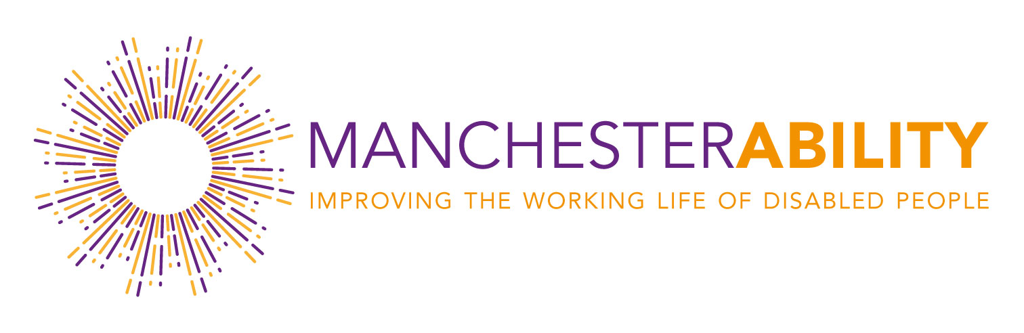
ManchesterAbility, launched on 26th March 2019, is a cross organisational forum in Manchester which brings government, companies and other organisations together to talk about the important issues surrounding disability and long-term health conditions in the workplace.
Working with government representatives to support national initiatives, our mission is to connect businesses and colleagues to share experiences, best practice and ideas and capitalise on this knowledge to support others on their journey to become more disability confident and inclusive.

Interested? Write to ManchesterAbility@kpmg.co.uk

